Registration No: 2025/CS/079
Index No: 25000799

( 01 )
- Highest – December
Lowest – January
Student performance has increased throughout the year.
- Student participation is higher in last five months, compared to the first four months.
- Student’s academic performance is higher in last few months compared to other months.
- Overall pass percentage might be around 93% and average final exam marks might be around 86.
With the incrementing pattern of average final marks and overall pass percentage, it is obvious that it is going to be increased in the following month (January of next year).
- Increase the student intake
- We can see from the data set that the number of students participating in the academic process is directly impact the overall pass percentage. So we can increase students’ academic performance with increased competition and peer pressure.
( 02 )

- Patient registration process :
  - Getting patient details.
  - Validating patient details.
- Appointment process :
  - Adding new appointments
  - Deleting existing appointments
- Medical records process :
  - Keeping a database for each person
  - Mapping the medical records with patients and their relevant doctor
- Functional decomposition helps to break down the problem into pieces so the developer can easily identify what kind of function he must implement, and what kind of processes requires the same kind of function. In this example the patient registration and medical record managing process both need to have a database to store patient details, and the appointment process should be able to retrieve data from it. That can be easily identified by breaking down the problem using functional decomposition.

( 03 )
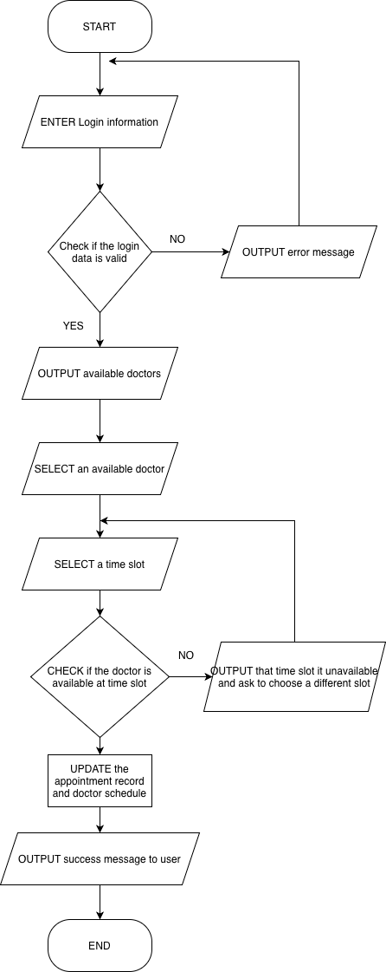

( 04 )
Two Sum
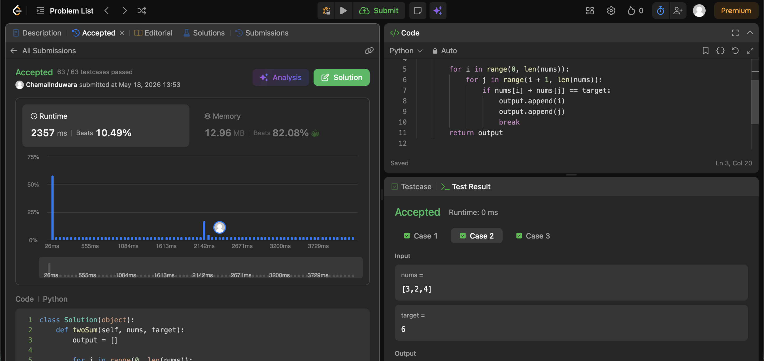
Palindrome Number
